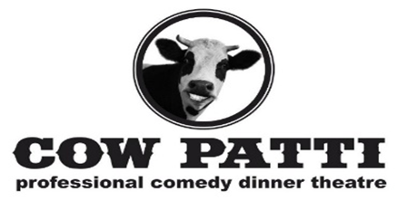
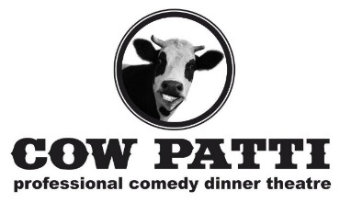
THE COW PATTI THEATRE COMPANY IS “MOOOO-VING” FORWARD IN OPENING OUR THEATRE GATES FOR THEIR 25TH SEASON OF PROFESSIONAL DINNER THEATRE!
COVID 19 GUIDELINES
We are excited to welcome you all back for our 25th Season on November 14, 2020. Due to continued restrictions from the Alberta Government we have implemented changes to ensure our productions can all be presented within Alberta Health Service (AHS) Guidelines and the Canadian Actors Equity Association Guidelines while still maintaining our commitment to deliver an exceptional dinner theatre experience. Below you will find a summary of how we plan to keep you safe in our Theatre.
SOCIAL DISTANCING
All areas of the Theatre have been addressed to allow for appropriate social distancing. This includes the lineup area, lobby, and washrooms. We have also added directional plop drops within the theatre to manage the flow of guests and avoid any congestion. The new Table Floor Plan will keep the 2-meter social distance needed between actors and patrons which will allow us an 80-person maximum with a cap of 6 people per table. We will be requiring that our patrons wear masks entering and leaving the theatre and moving in the space such as going to the bathroom. Because of our limited seating space we are encouraging people, that will be attending, to invite friends and family in their Cohorts to join them for an afternoon or evening with Cow Patti to best fill the tables to use the space as proficient as possible. As well, after each show the entire space at The Lacombe Golf and Country Club will be sanitized and cleaned.

SHARING POLICY
We will not be applying our usual sharing policy while social distancing is in effect. Once you purchase tickets, the table is yours and no other party will be seated with you. You are welcome to purchase any extra seats available at your table for members of your family or cohort to join you. Being we ultimately can only seat 80 people - we encourage our patrons to invite family members or friends in their cohorts to join them at Cow Patti so we can best utilize our limited seating capacity. If you would like to book in your Christmas Party we can accommodate up to 80 persons keeping in mind that we still have to separate people in groups of 6 maximum If you have a smaller group we will ensure to socially distance your party’s cohort from other patrons.

MEAL SERVICE
Given the number of guests in our theatre and the setup of our buffet line, we cannot effectively move our patrons through the buffet line in a safe and socially distant manner. Therefore, the Chef at the Lacombe Golf and Country Club and Cow Patti have created some new ways to “feed” our guests. They are simplified and create a way to safely serve our customers. Most importantly though, they will have our unique Cow Patti flavor: Lunenburger Night Homemade Burger with Fries and Slaw, Happi Appi Night : Choice of Wings, Ribs or Cauliflower Bites, Seniors Socially Distance Socials: Sandwiches, Wraps, Squares and Chocolate Covered Strawberries , Flapjack Sundays /Continental: Pancakes, Bacon, Eggs and Fruit or Croissant, Sweet Bun, Meats, Chesses and Chocolate Covered Strawberries and our Socially Conscious Benefits which will be the Happi Appi or Social Menu. We are also offering up some Cabaret Shows that have no food but will have a bar service for patrons to enjoy the show with a refreshment

SANITIZATION, MASKS AND TABLE FLOOR PLAN
We have adjusted our seating capacity and table layout to allow for two meters between all tables Hand sanitizing stations have been added throughout the Theatre and all surfaces are disinfected regularly. Our Servers and Bussers will all be required to wear a face mask and gloves, which will also be changed regularly. This means that masks will be required to enter the Theatre and when moving about to use the washroom, but you are free to remove the mask when you are seated at your table. You may bring your own mask from home or we will have disposable masks available for purchase.
WHEN WILL TICKETS GO ON SALE?
Tickets for the first production of the season LUNENBURG by Norm Foster go on sale September 9th 2020. The remaining productions of our 25th Season will be on sale in December. If you would like to be placed on a waiting list for first call backs, please email us at theatre@cowpatti.com

WHAT if I HAVE a CREDIT FROM the PRODUCTION of LUNENBURG
For our guests that took a credit from their purchased tickets from our original production of Lunenburg - we look forward to seeing you and having your support in bringing the lights back up on our stage. Account credits never expire and can be used in many ways – such as the purchase of tickets for Lunenburg or future performances. It can also be used to purchase of a gift card, or it can be gifted back to the theatre as a donation. Please visit our website under “Cattle Credits” which will take you through the steps in using your Lunenburg credit. There is no rush to use this account credit, so please give us a call or email us when you are ready to do so.
WHAT IF I STILL HAVE A QUESTION?
Please call AnnaMarie at 403 304 6329 or send a message via theatre@cowpatti.com

